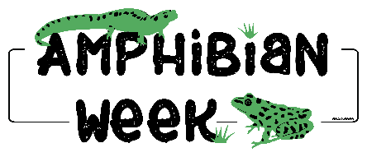

Watercoloring Wildlife: San Martin Fringe-limbed Treefrog

Supply List:
- Downloaded and printed pdf sketch of San Martin Fringe-limbed Treefrog.

  - Print directly to watercolor paper or transfer sketch to watercolor paper*
*Using watercolor paper will be optimal; using watercolor paint and techniques does not usually work well on standard copy/printer paper. If you choose to run watercolor paper through your printer, be sure to check your printer manual and settings to ensure it can take a thicker paper, such as watercolor paper. The watercolor paper may need to be trimmed to fit. The pdf is formatted to 8.5 X 11 inch paper. Alternatively, use other methods to transfer the sketch to watercolor paper.
- A watercolor set with solid watercolor paints.

- Some basic watercolor brushes. A few rounds and flats of various sizes. It would be good to have a couple small ones for details and then a couple larger for washing in large areas.

- Some artist tape or blue painters tape used for painting sold at hardware stores (or the green, “Frog Tape” version :)

- A cup of water and some paper towels.

